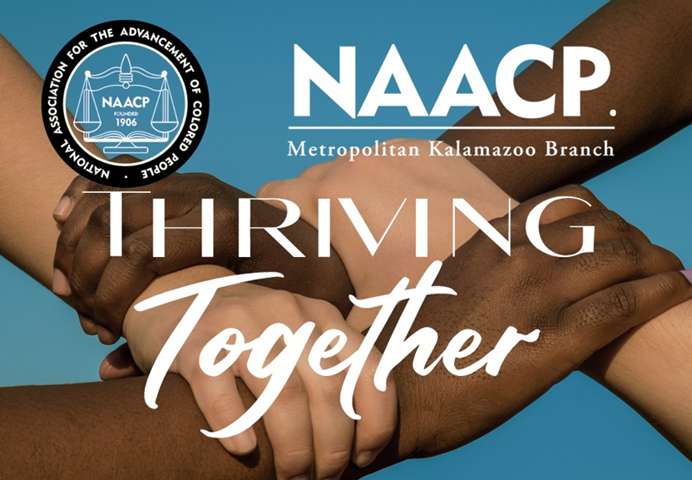

Metropolitan Kalamazoo Branch / NAACP
Humanitarian Award

Since 1979, the Metropolitan Kalamazoo Branch NAACP has honored an individual(s) from the community whose significant contributions have improved the lives of people of color in the areas of politics, education, religion, civil rights and/or community service.

Criteria & Guideline
The nominee should
- Influence people, policy and thinking about politics, education, religion, civil and human rights issues that affect people of color in the greater Kalamazoo community and beyond
- Positively affect lives through community service and other civic activities to impact the greater Kalamazoo community and beyond
- Effectuate change in the greater Kalamazoo area and beyond

Application
Applications can be found online (www.naacpkalamazoo.org/nominations). Those interested in nominating a person for the Humanitarian Award should complete the application by Friday, September 22, 2023 by 11:59pm EST. Only computer-generated applications will be accepted. Nominator may provide newspaper articles/clippings, personal profiles and/or resumes to supplement the application.

Nominations can be found and completed online, visit www.naacpkalamazoo.org/nominations emailed to info@naacpkalamazoo.org. If mailed, nominations must be received by the application deadline.

Humanitarian Award Recipient
The winner of the Humanitarian Award will be honored during the 2023 Freedom Fund Banquet, Saturday, October 28, 2023 | 5pm | Radisson Hotel (100 W. Michigan Ave.) The honoree will receive three (3) complimentary tickets, which include the honoree and two (2) guests.

For more information or questions, contact info@naacpkalamazoo.org.

Nominator’s Information

Nominator’s Name

Nominator’s Email Address |  | Nominator’s Phone Number
Relationship to the Nominee
Nominee’s Information

Nominee’s Name | mail Address
Nominee’s Email Address |  |  | Nominee’s Phone Number

List activities/organizations in which this person is affiliated
Including sorority/fraternity/mason, clubs, community organizations

Contributions that qualify nominee for this award
Including involvement with civil rights, civic engagement, education, religion, human rights, politics, etc.

How has the nominee gone above and beyond to help people of color in the greater Kalamazoo community?

List humanitarian efforts (concern for human welfare) in which the nominee has been involved

Additional information for consideration
Please include websites or sites with additional information about the nominee

Supplemental Information

I hereby certify all the above information is true and accurate to the best of my knowledge. Any intentional misrepresentation or omission of facts will be justification for denial of this award.

_____________________________________________________ __________________________________
Signature Date

